ECE 5140/6140 Sensors and Instrumentation
Lab 1 – Wheatstone Bridges in Multisim
- List three sources of noise that can be minimized using a ratiometric circuit and 3 sources that can be eliminated using a differential circuit
- Create a Wheatstone quarter bridge in mutlisim or LTspice to measure a resistive sensor with an R₀ = 350 Ohm. Use Vr_{ef} = 10V.
  - What value should the other 3 resistors be set to?
  - Using multisim, measure the sensitivity of the bridge and sketch or plot a graph of the sensitivity as the bridge becomes increasingly unbalanced. To do this, start at with a balanced bridge and measure the sensitivity (covered in lecture) that results from a 2 Ohm change in the sensors impedance. Repeat this process for various bridge ratio’s (k). Measure 10 points for 10>k>1 (log spacing).
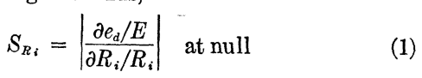
- Assume a strain gage with the following characteristics for this problem
R₀ = 120 Ohm @ 20º C
= 255 Ohm @ -50º C
= 1405 Ohm @ 800º C
R(2% strain) = 415 Ohm @ 20º C
= 298 Ohm @ -50º C
= 1650 Ohm @ 800º C
  - Explain the simplest method to compensate for the temperature using a bridge. Include details on how many sensors, where they connect, and when signals/noise sources they should be exposed to. If using resistors in the circuit, what characteristic should the resistors share with the sensor(s)?
  - How might you insulate the sensors form the signal/noise source as required in part a?
  - Algebraically show that the output is not affected by temperature. The following equation represents the resistance of the strain gage
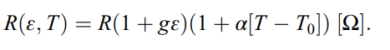
where ge is the strain and (1 + ge) = 1 when subjected to no strain
  - Using multisim, what is the output of the bridge with a reference voltage of 10V for the range 0 – 2% strain? Demonstrate that the temperature has no effect.
- Many sensors experience very small changes in resistance. For example, a strain gage may experience a deltaR = 0.1 Ohm/ mε, where ε is used to describe the change in length vs the initial length. What’s the worst-case scenario for sensitivity if you use resistors of +/- 10% accuracy? First consider the relationships between the resistors and then implement and measure the values using multisim.
- Now connect an amplifier circuit to provide additional gain to the output of the circuit.
  - Which of these amplifiers is more appropriate for the amplifier if the bridge circuit has values >10kOhm? LT1793 or the LT1363. You can find their datasheets online.
  - Compare the following topologies in your simulator. In the case of the first, set R1 = R2 and R3 = R4 so that the gain is
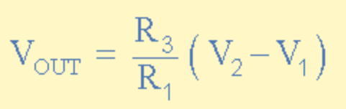
and in the case of the 2nd set R4 = R3 so that the gain is
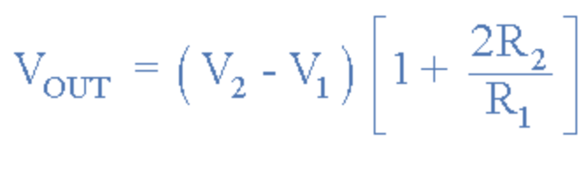
Choose an input range that keeps the sensitivity within 20% of the maximum. Use that range to determine the appropriate gain to achieve a 10V pk-2-pk V_{out.} Then, use a 100 Ohm load at the output and compare the signal delivered to the load if the gain is the same. Are they same? Why or why not?
